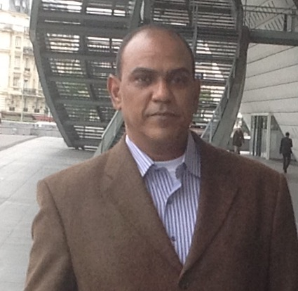 | Name Sherif Sayed Abdel-Rehim  First Middle Last
Date of Birth | 10/22/1963 Place of Birth : Assiut (EGYPT)
Nationality | Egyptian
Mailing address | Anesthesia Department – Faculty of Medicine  Assiut University, Assiut 71516 , Egypt
Academic Qualifications:  (M.B.B Ch), 1987  M.Sc, 1994  MD,2001 | -Faculty of Medicine Assiut University  -In Anesthesia and Intensive care medicine  The Title of thesis was: Comparative Study Between the Effect of H2-Blockers Versus Duration of Fasting on Gastric Volume and PH  -In Anesthesia and Intensive care medicine  The Title of Thesis was : Evaluation Of Two Methods of Weaning from Mechanical Ventilatory Support in Patients Recovered from Acute Respiratory Failure in the Intensive Care Unit.
Current Position | Assistant Professor in Anesthesia Department–Faculty of Medicine, Assiut University Egypt  Specialty: Anesthesia and Intensive Care.
Phone | 002 088 2314329  Mobil : 00201001732820
Fax | 002 088 02142708
E -mail | cherifsayed@gmail.com
Nature and place of work | Assistant Professor, Department of  Anesthesia Faculty of Medicine. Assiut University  Egypt
INTERNATIONAL CONFERECES HAD BEEN ATTENEDED
- International conference of 1st Malaysian Egyptian oncology conference HAND IN HAND AGAIST CANCER ,1st-2 May 2010 in Kuala Lumpur Malaysia
- International conference of European society of cardiology : Acute cardiac Care 20 October-22,2012 Istanbul-Turkey
- International Sepsis Forum, Sepsis 2013 , Paris Novemebr7-9 2012
- Euro-thrombosis Summit2013 , held in Uppsala , Sweden 3-5 October, 2013

